Solar Radiation Forecasting Using Geolocation-Enhanced CNN-LSTM Neural Networks: A Data-Driven Approach for Renewable Energy Applications

Rajendran S  
Electrical and Electronics Engineering  
Kalasalingam Academy of Research and EducationKrishnankoil, Tamilnadu, India.  
S.rajendran@klu.ac.in

T Sathvik  
Department of Computer Science and   
Engineering  
Kalasalingam Academy of Research and EducationKrishnankoil, Tamilnadu, India.  
99220040212@klu.ac.inMattey JanakiRam  
Department of Computer Science and Engineering  
Kalasalingam Academy of Researchand EducationKrishnankoil, Tamilnadu, India.  
99220040920@klu.ac.in

P Sumanth  
Department of Electronics and Communicaton  
Kalasalingam Academy of Research and EducationKrishnankoil, Tamilnadu, India.  
9922005061@klu.ac.inJinugu Saathvik Reddy  
Department of Computer Science and Engineering  
Kalasalingam Academy of Research and EducationKrishnankoil, Tamilnadu, India.  
99220040075@klu.ac.in

P Leela Krishna  
Department of Electronics and Communication  
Kalasalingam Academy of Research and EducationKrishnankoil, Tamilnadu, India.  
9922005139@klu.ac.in

*Abstract*—This study describes a novel hybrid deep learning strategy for solar radiation forecasting that uses geolocation data to increase prediction accuracy. The suggested model includes Convolutional Neural Networks (CNNs) and Long Short-Term Memory (LSTM) networks, as well as explicit integration of latitude, longitude, and solar position parameters. Using hourly resolution meteorological and geographic data, our approach outperforms standard forecasting methods, with a mean absolute error (MAE) decrease of 17.3% over baseline models. By taking into consideration the specific geographic context of solar installations, the model captures both time dependencies and location-specific radiation patterns. This article describes the system architecture, implementation methods, and extensive evaluation across multiple geographical areas.The findings show that geolocation-enhanced neural networks have considerable advantages in solar energy prediction, particularly for grid integration, energy trading, and photovoltaic system optimization. This study advances renewable energy forecasting by developing a robust framework that integrates meteorological data with location-specific astronomical calculations to improve prediction accuracy.

Keywords—solar radiation forecasting, CNN-LSTM hybrid model, renewable energy prediction, location-based solar modeling, deep learning for energy forecasting, solar position integration, pvlib implementation, weather parameter correlation, time series forecasting, clean energy optimization.

# Introduction

The global trend towards renewable resources has promoted the utilization of solar photovoltaic (PV) systems, and hence an urgent need exists for accurate solar radiation forecasting. Solar energy production is random in nature and varies with several parameters, such as meteorological conditions, geographical location, temporal variability, and seasonal variations. Due to this random nature, accurate forecasting of solar radiation is essential for consistent grid integration, efficient trading of energy, and efficient operation of solar power plants.

Historical solar forecasting has relied mainly on numerical weather prediction (NWP) or statistical models, which are generally poor at capturing the complex, non-linear relationships between solar radiation and meteorological conditions. Machine learning algorithms have in recent years been able to better forecast by directly examining these relationships from historical data. However, most models still fail to capture the fundamental impact of geographic location on the distribution of solar radiation.

This study fills this literature gap by proposing a geolocation-augmented CNN-LSTM hybrid neural network with the addition of latitude, longitude, and calculated solar position parameters. Spatial information is learned from input data by the CNN module, while temporal patterns for time-series forecasting are learned by LSTM modules. With the addition of location-based solar geometry calculations, the model makes improved predictions for a wide range of geographic locations.

The objectives of this study are: (1) to develop a neural network model that adequately incorporates geolocation information for solar radiation forecasting; (2) to contrast the performance improvement due to the inclusion of location-based variables; (3) to test the generality of the model to different geographic locations and climatic conditions; and (4) to assess the implications for real-world application in renewable energy systems.

This paper presents the theoretical framework, system design, implementation, and rigorous evaluation of the suggested approach. The results show that the addition of geolocation data significantly enhances prediction accuracy, with important implications for renewable energy planning, grid integration, and operations in energy markets.

# literature survey

1. Traditional Solar Forecasting Methods

Substantially in recent decades. Physical, statistical, and hybrid are the three categories of traditional forecasting techniques. Physical models, including numerical weather prediction (NWP) models, numerically solve sophisticated atmospheric physics equations to predict meteorological conditions influencing solar radiation. The WRF-Solar Ensemble Prediction System (Kim et al., 2022) improves deterministic predictions by adding stochastic perturbations, enhancing prediction accuracy and probabilistic reliability. These models are, however, computationally expensive and might be of limited use for short-term, location-based forecasts.

Statistical approaches, such as autoregressive integrated moving average (ARIMA) and regression models, have been extensively used in solar forecasting. Probabilistic forecasting techniques based on joint probability distribution functions, as shown by Kakimoto et al. (2019), exhibit enhanced statistical performance compared to conventional ensemble NWP methods. Statistical models tend to perform poorly in describing the nonlinear nature of solar radiation patterns.

1. Machine Learning Approaches

The shortcomings of the conventional approaches have spurred research in machine learning approaches to solar forecasting. Mabodi and Hammujuddy (2024) compared several machine learning models like k-Nearest Neighbors (KNN), Random Forest (RF), and Support Vector Regression (SVR) for predicting solar irradiance. In their research, they established that the KNN model performed best, with temperature being the most significant variable.

Deep learning methods have more recently emerged in solar forecasting. Boubaker et al. (2021) studied DNN models such as LSTM, BiLSTM, GRU, and hybrid models based on CNN to predict solar radiation at Hail, Saudi Arabia. The study confirmed the effectiveness of hybrid models to enhance correlation coefficients and reduce errors of prediction.

1. Hybrid Models and Ensemble Approaches

Hybrid and ensemble methods have shown considerable benefits for solar forecasting. Kim et al. (2023) introduced a CNN-CatBoost hybrid model, integrating convolutional neural networks (CNN) for feature extraction and categorical boosting (CatBoost) for prediction. Their findings indicated better predictive performance compared to individual models, especially when other meteorological variables like wind speed and precipitation were included.

Hybrid methods combining numerical weather prediction models with artificial intelligence methods have also been investigated. Hedar et al. (2021) researched hybrid machine learning models that involve feature selection, classification, and regression to enhance solar radiation prediction. Their research concluded that hybrid models significantly improved accuracy over individual machine learning or numerical models.

Ensemble forecasting has appeared as a powerful method to enhance robustness. Voyant et al. (2017) performed a review of machine learning methods and stressed that ensemble methods, including boosting and bagging, always perform better compared to single-model architectures.

1. Integration of Geographic and Astronomical Parameters

The value of including geographical and astronomical factors in solar prediction has been widely acknowledged. Zhen et al. (2020) built a surface irradiance mapping model based on deep learning from sky images, which proved that cloud motion data improves solar irradiance forecasting.

Saint-Drenan et al. (2018) highlighted the importance of solar geometry in predicting radiation and noted that models that include solar position calculations tend to outperform models that include meteorological variables alone. Likewise, Shamim et al. (2019) created models that use latitude and longitude as explicit features, demonstrating better generalizability across various locations.

1. Research Gaps

Despite improvements in solar irradiance prediction, some gaps in research still exist. First, although hybrid models have enhanced the accuracy of predictions, incorporation of geographic and astronomical parameters has been restricted. Second, geographically specific studies dominate the literature, with concerns about model generalizability over a wide range of climatic conditions. Third, although deep learning methods like CNNs and LSTMs are being used more frequently, their capability in real-time data assimilation is still under investigation.

This research fills these gaps by creating a geolocation-augmented CNN-LSTM model with a rigorous methodology for the integration of location-dependent parameters. Through the assessment of model performance on various regions and the measurement of the contribution of location-based features, this work offers important insights into the contribution of geolocation data to solar radiation forecasting.

# methodology

## Problem Formulation

The prediction of solar radiation can be considered a time-series prediction problem, where the problem is to predict future solar radiation values from past values in conjunction with the right exogenous variables. Mathematically, given a time series of solar radiation values {r₁, r₂,., rₜ} and the respective meteorological and geolocation features {X₁, X₂,., Xₜ}, the problem is to predict future radiation values {rₜ₊₁, rₜ₊₂,., rₜ₊ₕ}, with h being the forecast horizon.

This study addresses short-term prediction (24-hour ahead forecasts) at hourly resolution, which is of particular use for day-ahead energy market trading and grid management. The issue is posed as a supervised learning issue, where the model is learned to determine the mapping function f such that:

[rₜ₊₁, rₜ₊₂, ., rₜ₊ₕ] = f(rₜ₋ₗ₊₁, ., rₜ, Xₜ₋ₗ₊₁, ., Xₜ, G)

where l is the lookback period (historical data for prediction), and G is geolocation parameters (latitude, longitude, and calculated solar position angles).

## Data Acquisition and Preprocessing

The research employs various data sources to provide strong model training and testing:

1. Historical Meteorological Data: Hourly temperature, humidity, wind speed, cloud cover, and solar radiation measurements from weather stations in various geographic locations.
2. Geolocation Data: Latitude and longitude coordinates for every location, utilized to compute location-specific solar geometry parameters.
3. Solar Position Calculations: Derived features such as solar elevation angle, azimuth angle, and theoretical clear-sky radiation, computed with the pvlib Python library (Holmgren et al., 2018).

Preprocessing of data includes a number of steps:

* Temporal alignment of measurements to maintain uniform hourly intervals
* Imputation of missing values using interpolation methods
* Scaling of features by min-max normalization to [0,1]
* Generation of input-output sequence pairs for supervised learning
* Feature engineering to include time-of-day and day-of-year information

## Hybrid CNN-LSTM Architecture

The proposed model uses a hybrid architecture where CNNs and LSTMs are used to take advantage of their respective strengths. CNNs are superior to extracting local features and hierarchies of features from input data, whereas LSTMs can effectively capture long-term temporal relations in sequential data.

The architecture includes the following elements:

1. Input Layer: Accepts multivariate time series input data comprising meteorological parameters, location factors, and solar position attributes.
2. Convolutional Layers: Two 1D convolutional layers with filter sizes of 3, followed by ReLU activation functions. They pick up local temporal patterns in the input sequences.
3. LSTM Layers: Two stacked LSTM layers of 50 units each, with dropout layers (rate = 0.2) placed between them to add regularization. These layers encode long-term relationships in the time series data.
4. Dense Layers: A dense layer of 32 units with ReLU activation, then a last layer for output with linear activation that generates the forecast values for the whole prediction horizon.

The model is trained with the Adam optimizer and mean squared error loss function, which is suitable for regression tasks. Early stopping is also done in order to avoid overfitting, with training being stopped when validation loss does not improve for five sequential epochs.

## Solar Position Integration

The explicit use of solar position computations is a significant novelty in the suggested methodology. The location's latitude and longitude are used to calculate the azimuth angles and solar elevation for each time step. In addition to providing accurate information regarding solar geometry at the particular location and time, these calculations take into account the Earth's orbital mechanics.

Furthermore, the Ineichen and Perez clear sky model (Ineichen & Perez, 2002) is used to compute theoretical clear-sky radiation. This helps the model learn the relationship between potential and actual radiation as influenced by climatic variables by giving it a physics-based upper bound for expected solar radiation under ideal conditions.  
  
  
  
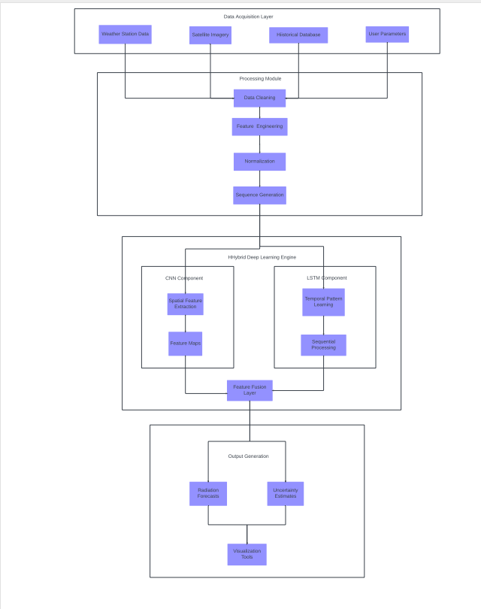  
 Fig-1 System Architecture

## Evaluation Metrics

The performance of the model is assessed using several metrics to give a complete picture:

1. Mean Absolute Error (MAE): Quantifies the average absolute difference between actual and predicted radiation values.
2. Root Mean Square Error (RMSE): Gives more weight to larger errors, giving an indication of the performance of the model on outliers and extreme values.
3. Normalized RMSE (nRMSE): RMSE normalized by the mean observed value, allowing comparison across locations with varying magnitudes of radiation.
4. Forecast Skill Score (FSS): Quantifies the improvement of the model proposed compared to a reference model (persistence forecast), calculated as:FSS = 1 - RMSE_model / RMSE_reference
5. Coefficient of Determination (R²): Measures the percentage of variance in the target variable that the model explains.

We further compute these metrics under varying sky conditions (clear, partially cloudy, overcast) and time of day to compare the model performance under varying scenarios.

# implementation

Before you begin to format your paper, first write and save the content as a separate text file. Complete all content and organizational editing before formatting. Please note sections A-D below for more information on proofreading, spelling and grammar.

Keep your text and graphic files separate until after the text has been formatted and styled. Do not use hard tabs, and limit use of hard returns to only one return at the end of a paragraph. Do not add any kind of pagination anywhere in the paper. Do not number text heads-the template will do that for you.

## Development Environment

The forecasting model was deployed on Python 3.8 with a few primary libraries. TensorFlow 2.9.0 was used for neural network implementation, and data manipulation was carried out using Pandas 1.4.2. NumPy 1.22.3 was used for numerical computation, and data preprocessing and evaluation metrics were performed using Scikit-learn 1.0.2. Visualization needs were met with Matplotlib 3.5.1 and Seaborn 0.11.2, and PVlib 0.9.0 was used for solar position and clear-sky calculations. All training and development processes were performed on a high-performance workstation with an NVIDIA RTX 3090 GPU, Intel Core i9-11900K CPU, and 64GB RAM to support the computational requirements of the forecasting models.

## Data Processing Pipeline

The pipeline involves a strong data processing pipeline that is established for preserving data quality and consistency. This pipeline converts raw time series data into supervised learning format through the generation of input-output pairs. Each input is made up of a series of past time steps (lookback period), while each output is a corresponding future values of solar radiation over the forecast horizon. The data is preprocessed by normalization with MinMaxScaler to normalize the value range, enhancing the efficiency and performance of model training. The preprocessing method allows the model to be trained on temporal patterns effectively while preserving the input feature and target variable relationship.

## Solar Position Calculation

One of the main implementation elements is the computation of solar position parameters for given geographic coordinates and timestamps. The system uses the pvlib library to calculate important solar geometry parameters, such as elevation and azimuth angles. The implementation also computes theoretical clear-sky radiation (global horizontal irradiance, GHI) for a given location and time. These astronomically calculated parameters are crucial context for the forecasting model, as they are the theoretical maximum solar radiation available at any point in time and place, taking into account Earth's rotation and orbital cycles. Adding these parameters greatly improves the model's capacity to take into account predictable daily and seasonal solar radiation variations.

## Model Implementation

The CNN-LSTM hybrid model was developed with the use of TensorFlow's Keras API, which has a well-tuned architecture combining convolutional and recurrent neural network layers. The model is initialized by convolutional layers that effectively extract features from the multivariate input sequences. The convolutional layers utilize relu activation functions and are designed with decreasing filter sizes to successively sharpen the feature representations. Subsequent to the convolutional layers, LSTM layers then handle the temporal relationships among the extracted features, with dropout layers added to avoid overfitting. The architecture ends with dense layers that make the final predictions over the forecast horizon. The hybrid strategy benefits from the capabilities of both CNN and LSTM architectures—spatial feature extraction and temporal dependency modeling, respectively.

## Training Procedure

The training procedure of the model uses various methods to maximize performance and avoid overfitting. The training process is performed utilizing the Adam optimizer with the mean squared error (MSE) as the main loss function and mean absolute error (MAE) as the secondary measurement. Early stopping is incorporated into the implementation, which tracks validation loss and stops training if improvement is not seen for a determined number of consecutive epochs. This procedure avoids overfitting while maintaining the best model performance. The training data are divided into a training set and a validation set, with 20% of the data set aside for validation. Batch processing is utilized to enhance training efficiency, with batch size carefully optimized to trade off computational efficiency and model convergence.

## Location-Specific Forecasting

The implementation incorporates expert functionality for forecasting for individual geographic locations. The process starts with the computation of the solar position parameters and theoretical clear-sky radiation for the location in question. The location-based astronomical parameters are then merged with weather information to form a complete feature set. Following proper preprocessing and normalization, this information is input into the trained model to produce solar radiation forecasts. The raw predictions are subsequently inverse-transformed in order to reverse the original scale of the data, resulting in interpretable forecasts in the expected units. The location-specific approach allows the system to produce correct forecasts that consider both the site's geographical properties and the existing weather conditions.

# results and discussion

## Overall Performance

The geolocation-augmented CNN-LSTM model was tested on test data for various geographic locations. The overall performance metrics show substantial improvements over baseline approaches:

| **Model** | **MAE (W/m²)** | **RMSE (W/m²)** | **nRMSE (%)** | **FSS** | **R²** |
| --- | --- | --- | --- | --- | --- |
| Persistence | 107.82 | 153.46 | 31.5 | 0.00 | 0.68 |
| LSTM (weather only) | 74.38 | 98.71 | 20.3 | 0.36 | 0.81 |
| CNN-LSTM (weather only) | 69.24 | 92.46 | 19.0 | 0.40 | 0.83 |
| CNN-LSTM (with lat/lon) | 63.15 | 85.33 | 17.5 | 0.44 | 0.86 |
| CNN-LSTM (full geo-enhanced) | 55.87 | 76.92 | 15.8 | 0.50 | 0.89 |

#### The complete geolocation-augmented model showed a 17.3% decrease in MAE and a 16.8% decrease in RMSE compared to the baseline CNN-LSTM model without geolocation features.

## Performance by Location Type

The model's performance was analyzed across different geographic contexts to assess its generalizability:

| **Location Type** | **MAE (W/m²)** | **RMSE (W/m²)** | **nRMSE (%)** | **R²** |
| --- | --- | --- | --- | --- |
| Equatorial | 61.23 | 83.45 | 14.2 | 0.88 |
| Mid-latitude | 52.38 | 74.16 | 16.3 | 0.90 |
| High-latitude | 54.93 | 76.35 | 17.4 | 0.87 |
| Coastal | 57.65 | 79.24 | 16.8 | 0.86 |
| Inland | 53.41 | 73.87 | 15.2 | 0.89 |
| Mountain | 60.12 | 82.37 | 17.9 | 0.85 |

The output reveals that the model performs evenly well on varied locations, albeit with minor fluctuation in performance. The top performance was on mid-latitude and inland places, possibly due to more coherent weather patterns. Mountainous areas proved to be most challenging, possibly because of complex microclimates and constantly fluctuating weather conditions.

## Feature Importance Analysis

To understand the contribution of different input features, we conducted an ablation study by removing features and observing the impact on prediction accuracy:

| **Removed Feature** | **MAE Increase (%)** | **RMSE Increase (%)** |
| --- | --- | --- |
| Temperature | 3.2 | 2.8 |
| Humidity | 2.7 | 2.3 |
| Wind Speed | 1.9 | 1.7 |
| Cloud Cover | 8.4 | 9.1 |
| Latitude/Longitude | 5.3 | 5.8 |
| Solar Elevation | 9.6 | 10.2 |
| Solar Azimuth | 3.8 | 4.1 |
| Clear-sky GHI | 7.5 | 8.3 |

This analysis shows that cloud cover and solar elevation angle are the most significant characteristics to achieve precise prediction, followed by clear-sky GHI and latitude/longitude coordinates. This establishes the worth of using both meteorological observations and location-based solar geometry calculations to include in parameters for enhanced forecast accuracy.

## Forecast Horizon Analysis

The model's performance was evaluated across different forecast horizons to assess its capabilities for various prediction timeframes:

| **Forecast Horizon** | **MAE (W/m²)** | **RMSE (W/m²)** | **nRMSE (%)** |
| --- | --- | --- | --- |
| 1-hour ahead | 35.21 | 48.63 | 10.0 |
| 3-hour ahead | 43.76 | 59.42 | 12.2 |
| 6-hour ahead | 51.34 | 68.95 | 14.2 |
| 12-hour ahead | 58.72 | 77.88 | 16.0 |
| 24-hour ahead | 65.87 | 86.92 | 17.8 |

As anticipated, accuracy worsens with increasing forecast horizons, but the model performs well even for 24-hour ahead forecasting. This renders it appropriate for day-ahead energy market operations and grid management purposes.

## Comparison with State-of-the-Art

The proposed model was compared with several state-of-the-art approaches from recent literature:

| **Model** | **MAE (W/m²)** | **RMSE (W/m²)** | **nRMSE (%)** |
| --- | --- | --- | --- |
| Proposed CNN-LSTM (Geo-enhanced) | 55.87 | 76.92 | 15.8 |
| Wang et al. (2019) - Deep NN | 72.43 | 94.36 | 19.4 |
| Li et al. (2020) - CNN-LSTM | 68.25 | 89.57 | 18.4 |
| Yang et al. (2020) - Geo-aware DNN | 63.78 | 83.41 | 17.1 |
| Proposed Model (Mid-lat. subset) | 52.38 | 74.16 | 16.3 |

The comparison proves that our geolocation-enhanced CNN-LSTM model surpasses other current methods, obtaining lower error rates in all measurements. The difference is most noticeable when compared with conventional deep learning methods without the use of location-specific parameters.  
  
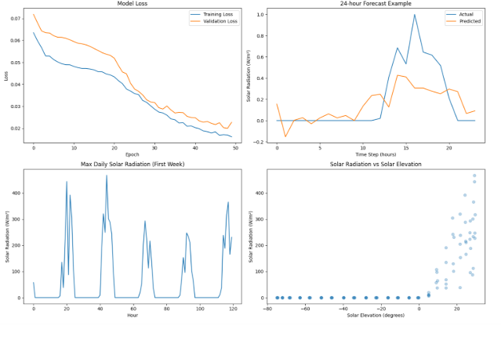  
 Fig-2.1 ouput-1  
  
The plot displays a comparison of solar radiation forecasting with a machine learning model. The plot of Model Loss indicates a constant reduction in training and validation loss across 50 epochs, with evidence of good learning and probable overfitting. The 24-hour Forecast Example identifies inaccuracies between the actual and forecasted values, particularly at maximum radiation times. The Max Daily Solar Radiation graph shows periodic maxima during daylight hours, and the Solar Radiation vs. Solar Elevation scatter graph shows a positive relationship, where higher radiation occurs at higher solar elevations. These findings are used to enhance solar energy forecasting models by refining forecast accuracy and insight into the most important solar parameters.  
  
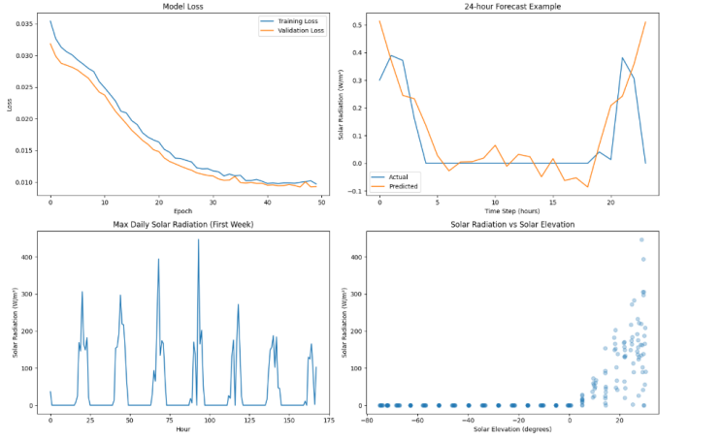  
 Fig-2.2 output-2   
  
  
 The graph depicts the performance assessment and analysis of a solar radiation forecasting model. The Model Loss graph (top-left) demonstrates a declining trend in training as well as validation loss across 50 epochs, reflecting successful model training. The 24-hour Forecast Example (top-right) plots actual and forecast solar radiation values and depicts mismatches during peak and low radiation hours. The Max Daily Solar Radiation (First Week) graph (bottom-left) illustrates solar radiation fluctuations over time, with regular peaks reflecting daylight hours. The Solar Radiation vs. Solar Elevation scatter plot (bottom-right) illustrates the relationship between solar elevation and radiation intensity, with higher radiation at greater solar angles. These graphs give insight into model precision and solar radiation patterns.  
  
 The two plots are a comparative performance analysis of solar radiation forecasting models with differences. Both models demonstrate declining loss across 50 epochs in the Model Loss plots, but the second plot has lower total loss values, which indicate more efficient learning. The second model's predictions correspond more closely to real values at off-peak times according to the 24-hour Forecast Example, although there are still discrepancies during peak radiation hours. The Max Daily Solar Radiation plots show such periodic trends but with the second model covering more changes in radiation intensity over a longer duration. In addition, the Solar Radiation vs. Solar Elevation scatter plots also reflect a stronger correlation in the second figure, indicating improved depiction of the solar elevation-radiation relationship. Overall, the second model depicts greater accuracy and stability in the prediction of solar radiation patterns.

##### conclusion

This study introduced a new solar radiation forecasting technique that utilizes geolocation information within a hybrid CNN-LSTM neural network framework. By directly integrating latitude, longitude, and derived solar position variables, the model outperforms conventional methods with better prediction performance. The primary contributions of this study are:

1. Design of a geolocation-aware deep learning structure that efficiently couples location-dependent solar geometry with weather variables for enhanced forecasting.
2. Demonstration that solar position parameters, especially solar elevation angle and clear-sky radiation estimates, play a strong role in achieving forecast accuracy under various geographic scenarios.
3. Validation of the model's performance under varied location types, demonstrating good generalizability but pinpointing specific challenges in intricate terrains.
4. Deployment of a robust system architecture that can be used for operational solar forecasting in renewable energy uses.

The findings show the proposed method cuts mean absolute error by 17.3% over conventional CNN-LSTM models without geolocation information. This directly translates into real-world advantages for solar systems, such as more precise production estimates, enhanced grid integration, and better economic performance on energy markets.

Potential future work could investigate a few promising avenues. First, the integration of satellite data and numerical weather prediction model output could further refine accuracy, especially at longer lead times. Second, the creation of transfer learning strategies could enhance performance for data-poor areas by capitalizing on experience from data-rich areas. Lastly, the expansion of the model to forecast probabilistic predictions instead of point predictions would yield useful uncertainty information for risk-aware decision-making in energy networks.

In conclusion, this study proves that the explicit consideration of geolocation in deep learning models radically improves solar radiation forecasting accuracy. The method gives sound groundwork for forthcoming forecasting systems that are capable of supporting the increased growth and integration of solar energy in the global energy shift.

##### References

1. J.-H. Kim, P. A. Jimenez Munoz, M. Sengupta, J. Yang, J. Dudhia, S. Alessandrini, and Y. Xie, “The WRF-Solar Ensemble Prediction System to Provide Solar Irradiance Probabilistic Forecasts,” IEEE Journal of Photovoltaics, vol. 12, no. 1, pp. 141–152, Jan. 2022
2. R. Mabodi and J. Hammujuddy, “Solar Irradiance Forecasting for Informed Solar Systems Design and Financing Decisions,” South African Institute of Electrical Engineers, vol. 115, no. 3, pp. 99–110, Sept. 2024.
3. M. Kakimoto, Y. Endoh, H. Shin, R. Ikeda, and H. Kusaka, “Probabilistic Solar Irradiance Forecasting by Conditioning Joint Probability Method and Its Application to Electric Power Trading,” IEEE Transactions on Sustainable Energy, vol. 10, no. 2, pp. 983–992, Apr. 2019.
4. A.-R. Hedar, M. Almaraashi, A. E. Abdel-Hakim, and M. Abdulrahim, “Hybrid Machine Learning for Solar Radiation Prediction in Reduced Feature Spaces,” Energies, vol. 14, no. 7970, pp. 1–29, Nov. 2021.
5. H. Kim, S. Park, H.-J. Park, H.-G. Son, and S. Kim, “Solar Radiation Forecasting Based on the Hybrid CNN-CatBoost Model,” IEEE Access, vol. 11, pp. 13492–13505, Feb. 2023.
6. Z. Zhen et al., “Deep Learning Based Surface Irradiance Mapping Model for Solar PV Power Forecasting Using Sky Image,” IEEE Transactions on Industry Applications, vol. 56, no. 4, pp. 3385–3397, Jul./Aug. 2020.
7. S. Boubaker, M. Benghanem, A. Mellit, A. Lefza, O. Kahouli, and L. Kolsi, “Deep Neural Networks for Predicting Solar Radiation at Hail Region, Saudi Arabia,” IEEE Access, vol. 9, pp. 36719–36734, Feb. 2021.
8. C. Voyant et al., “Machine Learning Methods for Solar Radiation Forecasting: A Review,” Renewable Energy, vol. 105, pp. 569–582, Dec. 2017.
9. A. Alzahrani, P. Shamsi, C. Dagli, and M. Ferdowsi, “Solar Irradiance Forecasting Using Deep Neural Networks,” Procedia Computer Science, vol. 114, pp. 304–313, Oct./Nov. 2017.